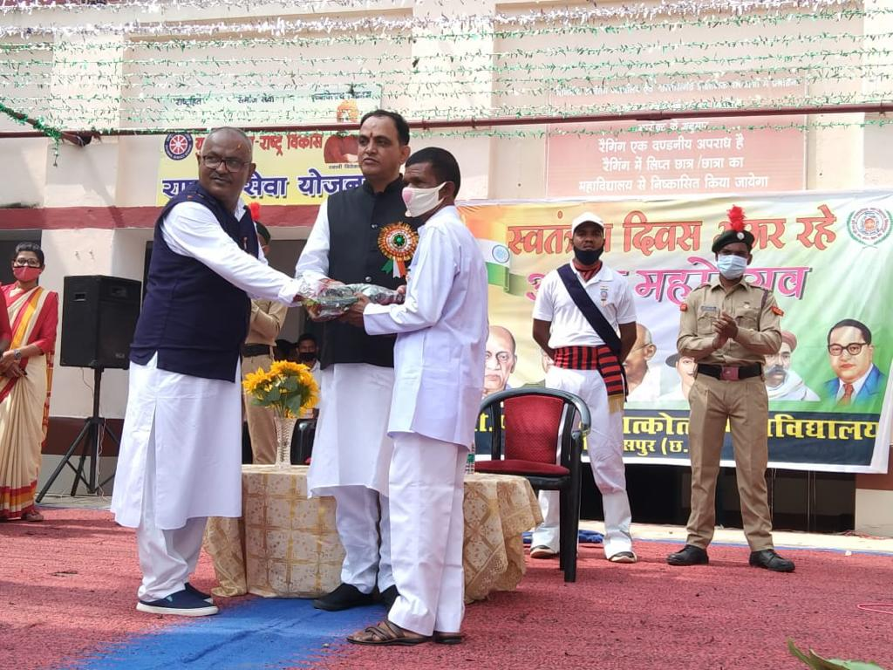
Recognition of employees for excellent work
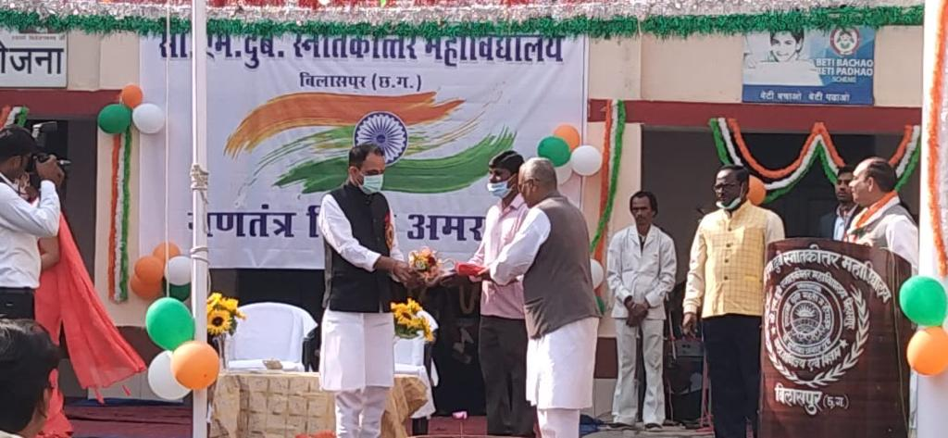
Shri Enaram Gond Ji

Shri Mahaveer Neti Ji
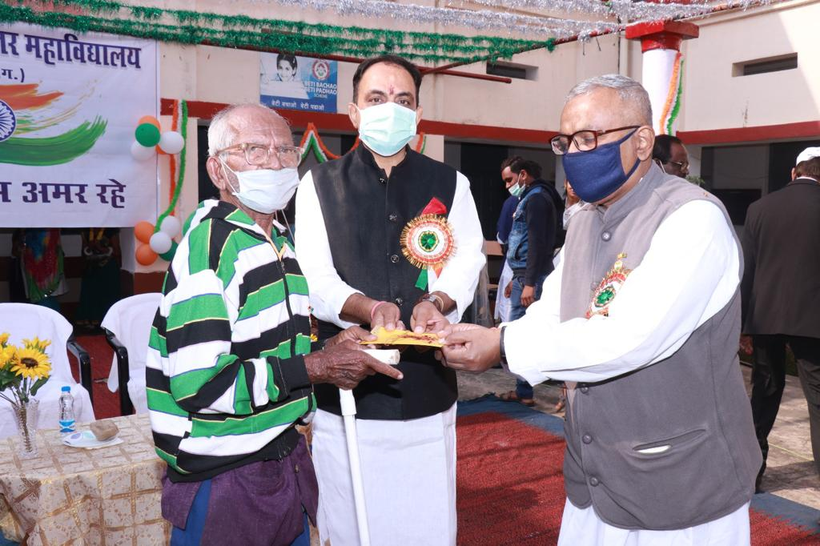
S

Shri Mohan Gedam Ji
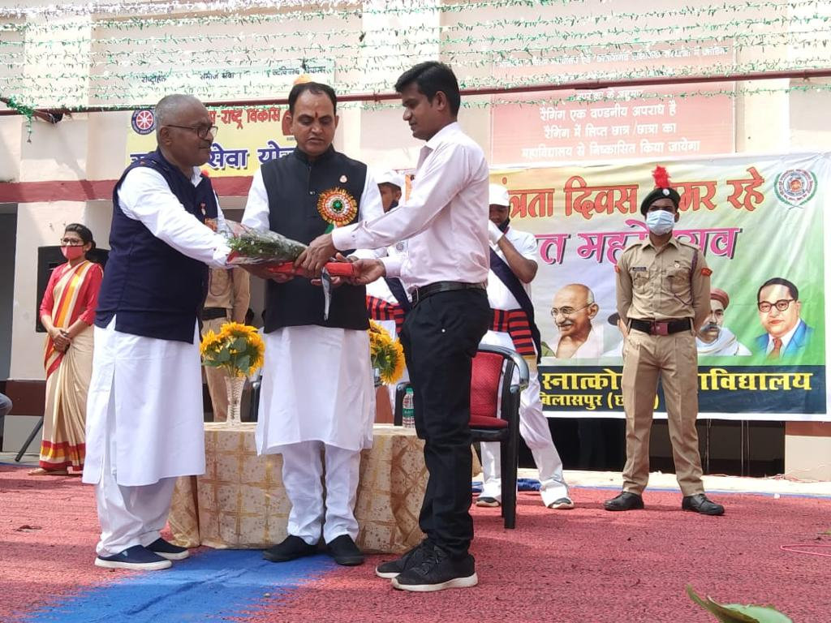

Shri Vijay Yadav Ji
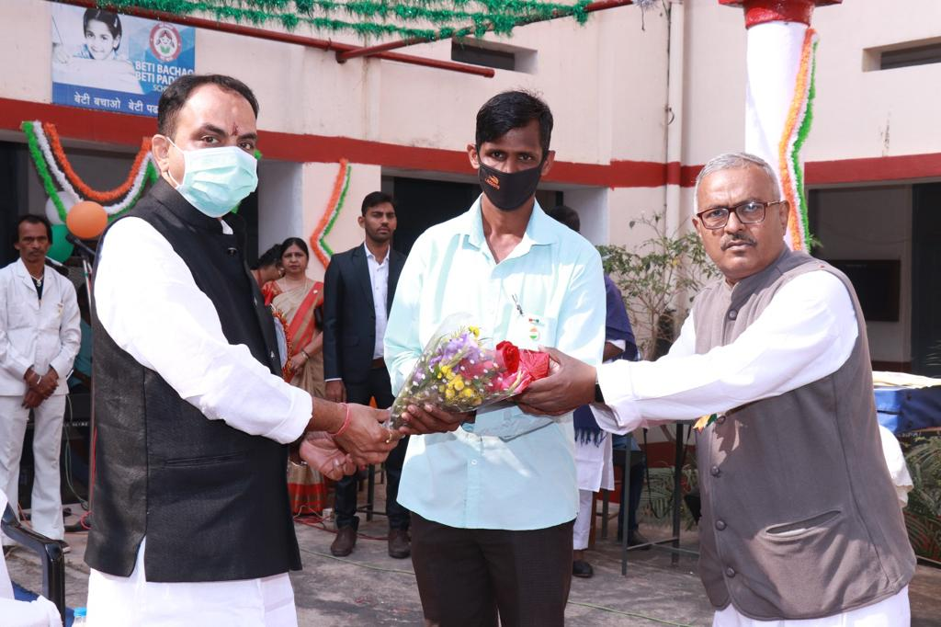

Shri Ram Manohar Kaushik Ji
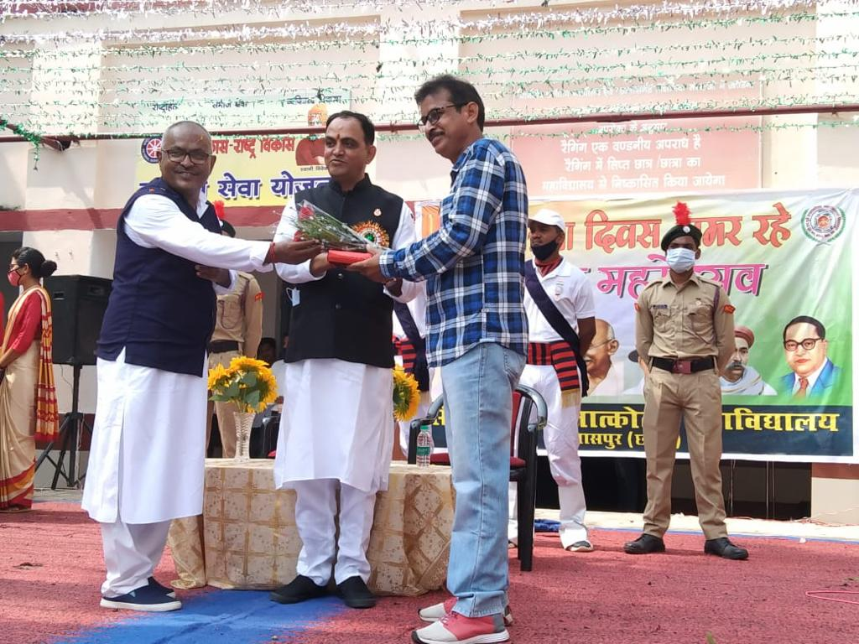
Shri Arunendra Dwivedi Ji
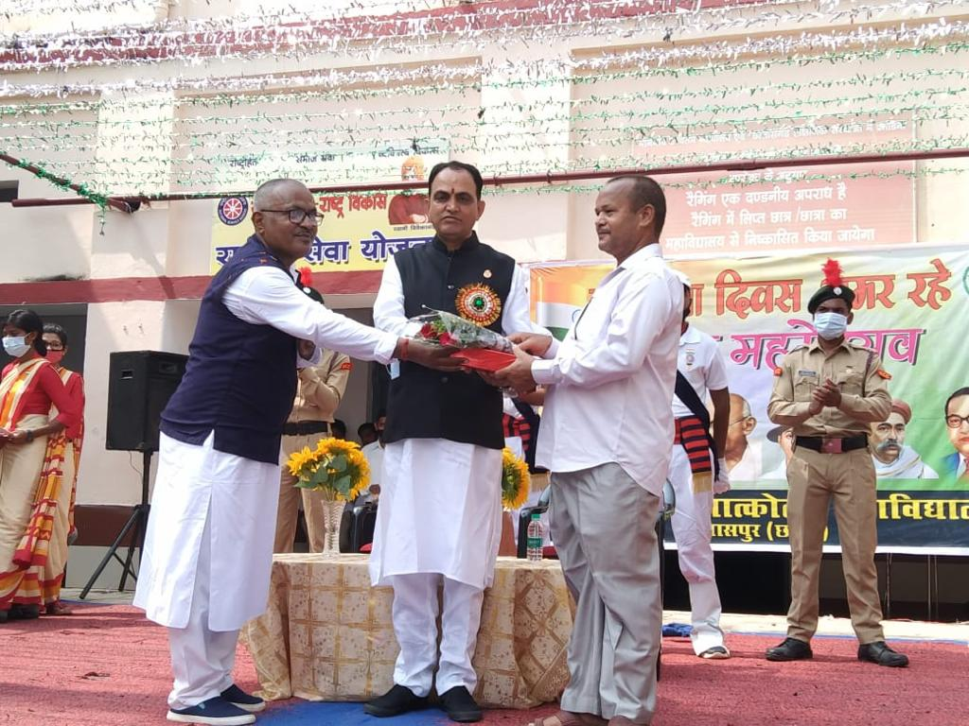

Shri Ramesh Shriwas Ji
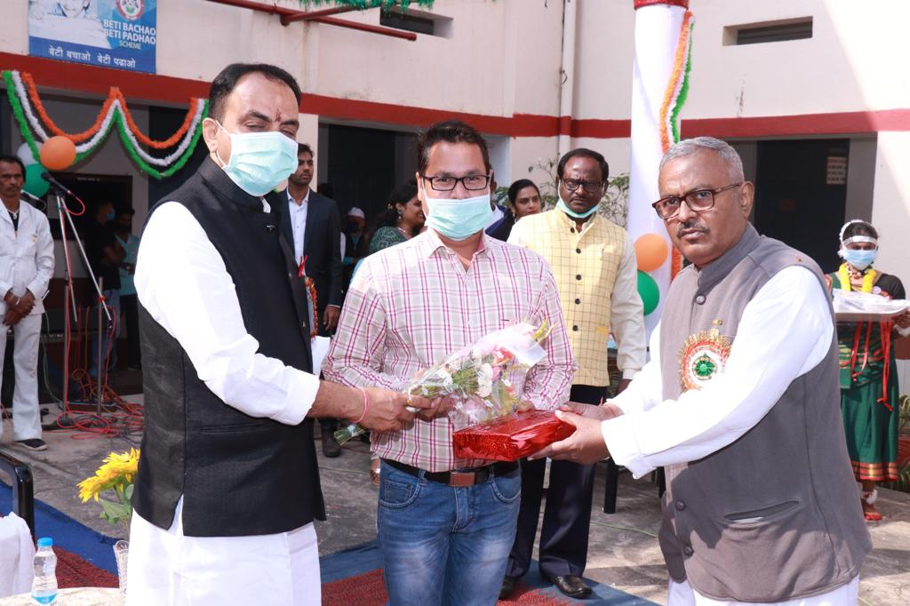

Shri Ashutosh Kashyap Ji
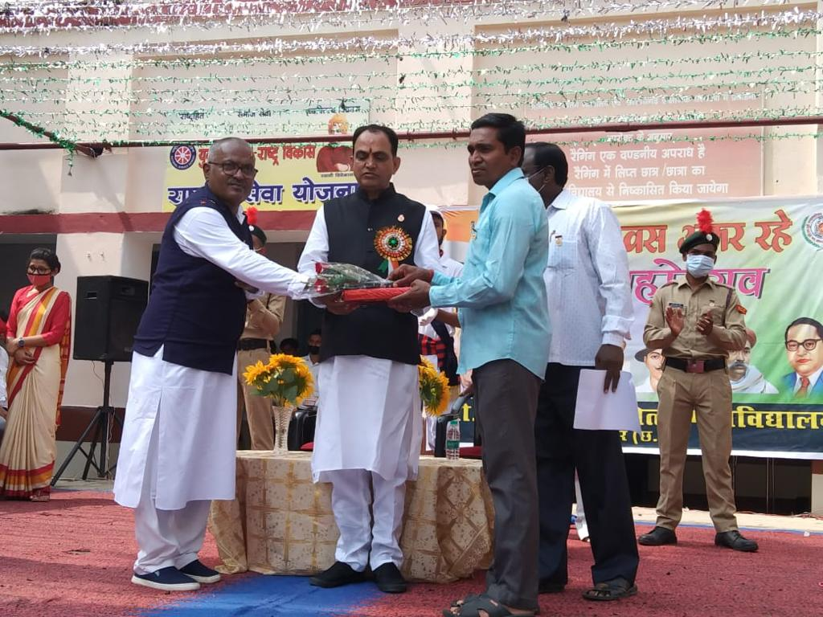

Shri Rameshwar Sahu Ji
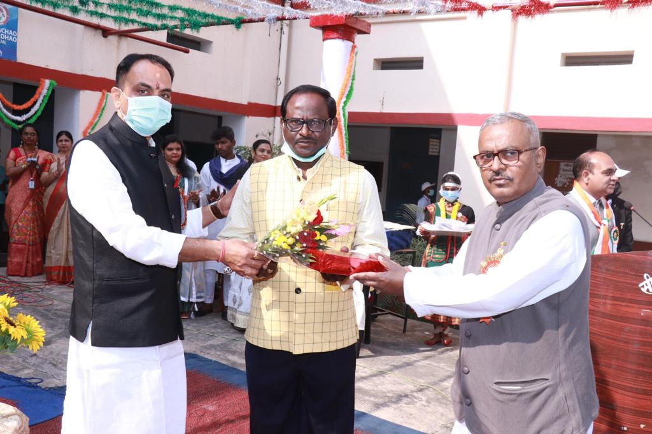

Shri Kaushal Gupta Ji

